Journey in Palestine listening to the call for peace with justice
Speaker: Pat Gaffney, former director of Pax Christi, and now Chair of the Kennington Bethlehem Link
Pat makes regular visits to the region and was in Palestine and Israel in October 2019. She will reflect on her recent visit, highlighting the challenges and opportunities for those who work for peace and human rights.
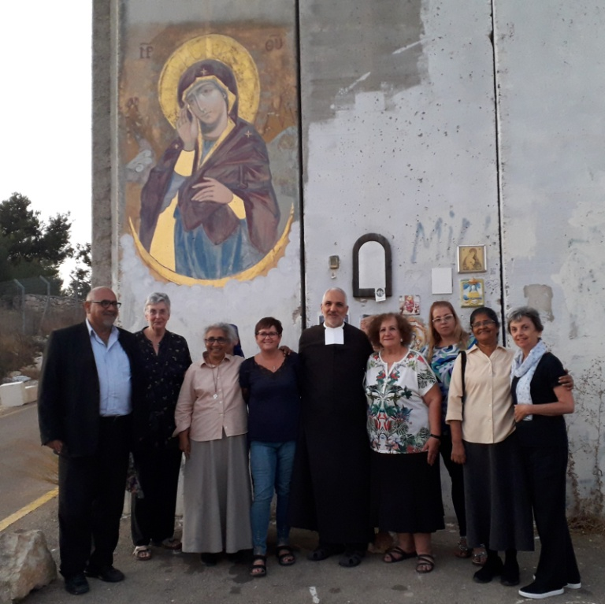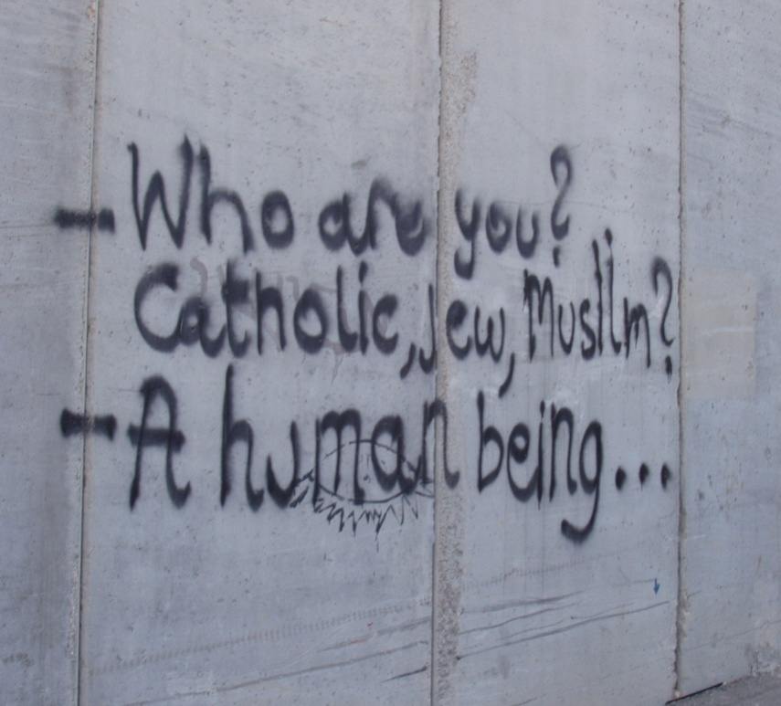
Praying at separation wall Message at separation wall

Monday, 30th March 2020 at 7:30pm in
Corpus Christi RC Church, Brixton Hill (entrance to the Church Hall is on Trent Road)
Transport: Tube, Victoria Line to Brixton Buses: 45, 59, 159, 250, 333

